Source file

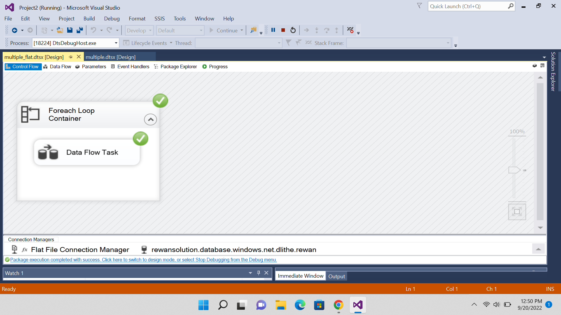

Destini file

